Vehicles sales platform

This is a technical report for the software platform to show all vehicles available to be sell in the company.

1. User Histories: For the development of this project, we used the user stories that were defined in the first workshop and we added and modified some in base with the new needs of the client. Obtaining the following:

* Each vehicle has at least engine, chasis(A or B), model, gas consumption, and year.
* Depending on the vehicle type, you should define additional properties.
* There are different vehicle types: car, Truck, Yacht, and Motorcycle.
* Each engine has type, potency, and weight.
* To calculate the vehicle gas consumption, you could create a method based on: 1.1 * engine.potency + 0.2* engine.weight - (0.3 if chassis ==A or 0.5 if chassis == B).
* The platform should have a simple menu to create vehicles, review all vehicles registered
* As manager I want a option to the user can be authenticated for that Know who is the person that access to the system, if is a employed add his employed code.
* As manager i need that a external user just can searchs and watch vehicles
* As external_user i can watch a menú witch the options that i can use
* As employd i want a menú that showme all the options that i can do.
* As manager I want that my employes can: créate new cars for the catalog, show the cars that are in the catalogue, créate parts for the vehicle, and show that parts.
* As manager i want that the external users can see all the specifications vehicle and the price of the vehicle
* As manager I want show a list of all the sell products

1. CRC Cards: In base on the class diagram seen in Figure 1, was made, the next CRC cards

|  |  |
| --- | --- |
| Engine | |
| Responsibility | Collaborators |
| Provide information | Vehicle  Main_menu |

|  |  |
| --- | --- |
| Vehicle | |
| Responsibility | Collaborators |
| * Provide information about vehicles * Calculate vehicle consumption based on engine and chassis information | Engine  Main_menu |

|  |  |
| --- | --- |
| Main_menu | |
| Responsibility | Collaborators |
| * Validate user’s role in order to define functionalities * Show a menu witch diferents functionalities for the user | User |

|  |  |
| --- | --- |
| User | |
| Responsibility | Collaborators |
| * Save the data of all the user’s | Main_menu |

1. Diagrams

* 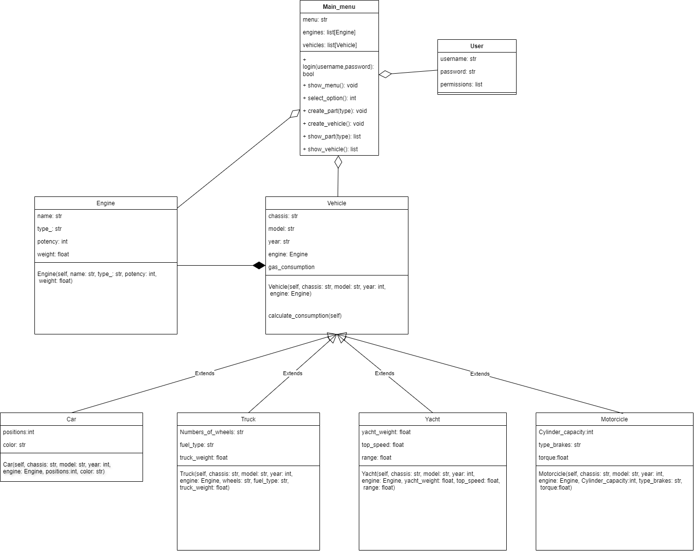Class Diagram

**Figure 1 Class Diagram**

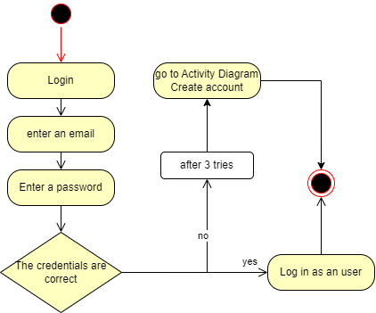Activity Diagram Login:

* 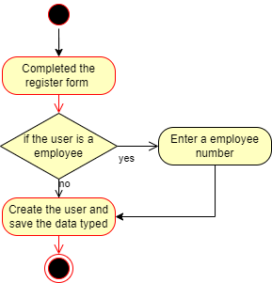Activity Diagram Create account:
* 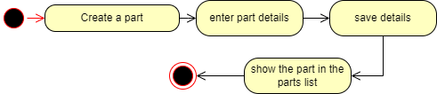Create a vehicle part
* 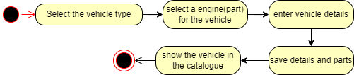Create a vehicle